University Of Waterloo

MTE 100 / GENE 121

Interim Design Report

Group 425

Aniket Phanse, Bharath Srinivas, William Kwong, Ryan Zhou

Table of Contents

List of Figures iii

List of Tables iii

1 Introduction 1

2 Scope 1

3 Constraints and criteria 2

3.1 Constraints 2

3.2 Criteria 2

4 Design 3

4.1 Design A 3

4.2 Design B 4

4.3 Design C 5

5 Design Decision 6

6 Project Plan 7

7 References 8

List of Figures

Figure 4.1 Design A [1] 6

Figure 4.2 Design B [2] 7

Figure 4.3 Design C Sketch Side View 8

Figure 4.4 Design C Front and Top View 8

List of Tables

Table 6.1 Project Plan Chart 10

# Introduction

Engineering Graphics and Design is a difficult subject especially since there is a lot of visualization skills required (particularly in the missing lines assignment) and hence many students struggle in their first few weeks of the class. Additionally, almost every assignment requires work from a computer software such as AutoCAD to be printed out and not every student has a printer to conveniently print their designs. Our project is a small step to try and help these students. Our goal is to build a robot that will be able to input a type of drawing file and convert those into instructions to use a drawing tool such as a pen, pencil or a marker to physically draw it out on a given paper. This way students can simply use this robot to print out their given work using tools they have at home, without having to pay for a printer or ink.

# Scope

The physical resource given to us for building this robot is an extended LEGO Mindstorm EV3. Our robot’s task is to simply draw, on a piece of paper, the file inputted into the program, using a pencil, pen or a marker. For it to do this, the robot will need a few inputs as follows:

* What to draw – This will be the file in the form of a .dwg or .svg for the robot to convert to mechanical instructions.
* What to draw on – This will be the size of the paper so that the robot can scale the drawing accordingly and hence make it more accurate.

As the robot plots the given file on the paper it uses affect its surroundings in the following way:

* Movement – For the robot to draw on the paper, either the drawing tool will me moved over the paper or the paper moved in different directions while the pencil will be kept stationary.

We have defined the job to be successful if the produced drawing on the paper resembles the original drawing in the file and all functions in the code of the program work as they are designed to. As we investigate with motor speeds and different pressures applied by the drawing tool on the paper, we will define a quantity to measure and increase its accuracy. As of now, failure by the robot is clearly defined. If the robot does not produce any drawing at all, because of reasons such as software errors or physical failures, or if the final drawing produced is skewed in such a way that it does not resemble the original drawing, then the robot and our project fails the test.

# Constraints and criteria

## Constraints

The constraints for our design that our team decided to agree upon are:

* Must be able to draw with a minimum thickness of 0.05mm thickness when provided with a pencil of 0.5mm thickness.
* Must be able to draw on a standard A4 size plain paper.
* Drawing must reasonably resemble the original drawing in the file.
* Drawing tool must be able to reach every x and y coordinate mapped on the paper.
* Drawing tool must be restricted to the paper and not draw anywhere outside the paper.

## Criteria

Based on the above constraints and project requirements our designs will be judged in the following criteria:

* Complexity of code: The simpler the code, and the easier it is for the robot to understand where on the paper it is drawing, the higher the design scores in the category.
* Accuracy of drawing: Here, we talk about the quality of the drawing, including how straight the lines are, how accurate the angles are, how smooth the curves are and if the thickness of the lines is consistent or not.
* Efficiency of robot: If the robot takes too long to make simple curves, because the design involves only one degree of movement at a time, it doesn’t score high in this category.
* Convenience in using robot: This defines how easy it is to print a file using the design of the robot.

# Design

After brainstorming over a weekend, researching on how printers work and what would make our code easier, we narrowed our ideas down to three viable designs.

## Design A

This design resembles the standard configuration of the EV3 robot in GENE 121. It is modified to mount a drawing tool in its rear side. The mechanism is attached to the small motor which is used to raise and lower the drawing tool. To draw the robot drives itself over the paper which it understands using the color sensor mounted at its bottom.

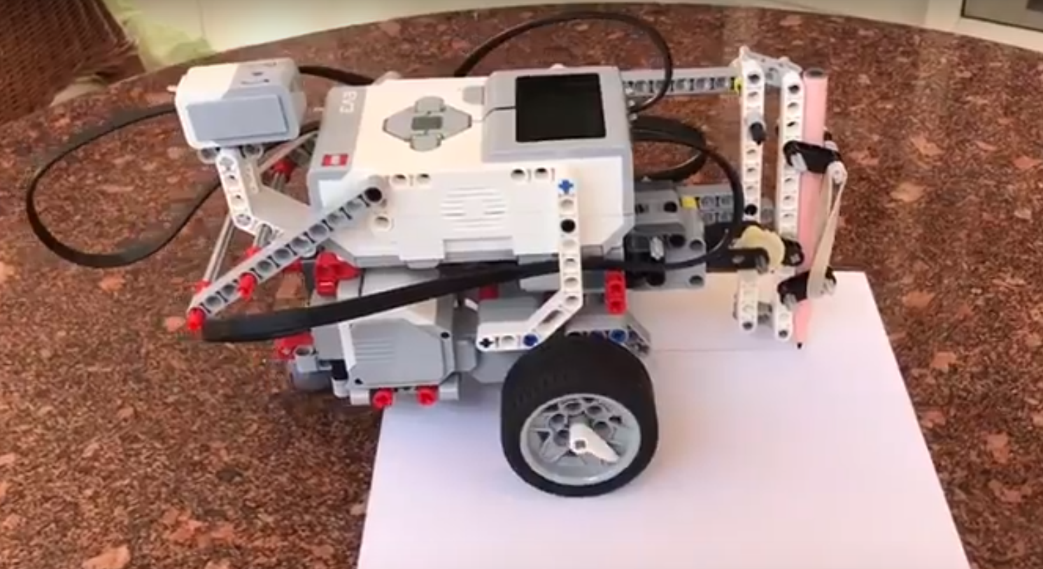

Figure 4.1 Design A [1]

## Design B

In this design the paper is placed next to the brick of the robot which is attached to motors which in turn control a sideways arm that hovers over the paper and draws using this arm.

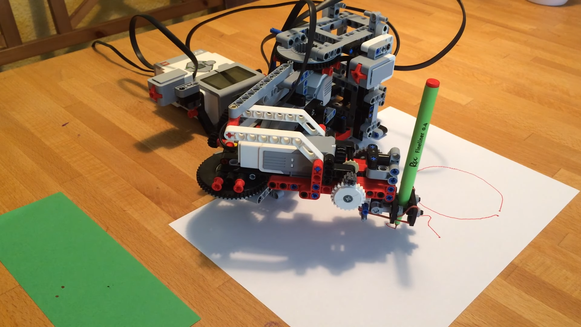

Figure 4.2 Design B [2]

## Design C

This is a little more complicated but a more printer-like design. This includes a moving belt on which the drawing tool is mounted. As this belt moves, the drawing tool moves horizontally across the paper. The paper is on a base on which few rubber wheels (controlled by a motor) rotate which either pushes the paper forward or pulls it back depending on direction of rotation [3].

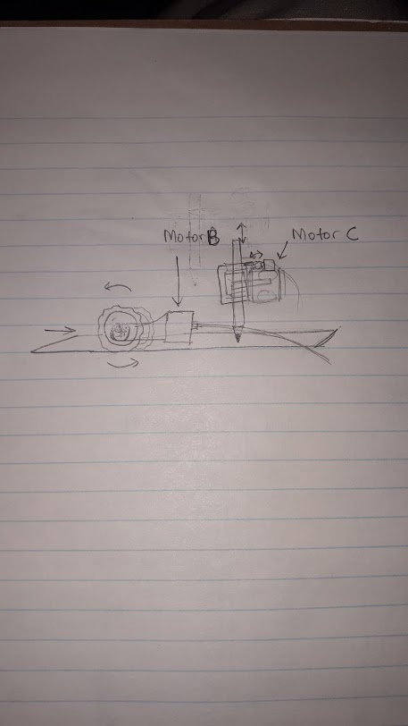

Figure 4.3 Design C Sketch Side View

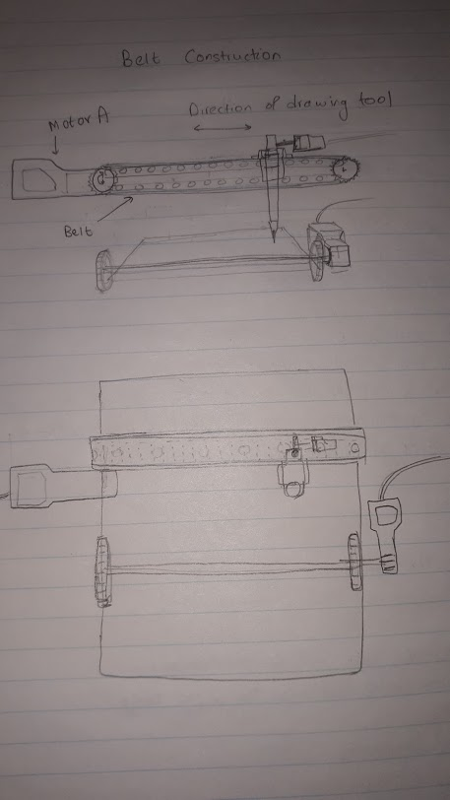

Figure 4.4 Design C Front and Top View

# Design Decision

Based on the criteria that we said a few observations can be made about each design:

* Design A is very convenient to use as you can just place it on or near the paper and it drives itself to draw. But mapping the paper’s coordinates onto the program is very difficult as the robot could be placed anywhere and is therefore, extremely difficult to code. Additionally, the accuracy of the drawing is not the best as while robot turns it can change the orientation of the paper.
* Design B is a little less convenient as it is slightly bigger and heavier than Design A. Yet, it is easy to map the paper to the program as the position of the robot relative to the paper is less varied than Design A, and hence is easier to code. It is less efficient because different parts of the paper require different orientations of the arm (using linear algebra). Any curve or line extending through these different parts will require time for the robot to adjust its arm accordingly. Since, the robot is stationary and only the arm moves over the paper, its accuracy is much higher than Design A.
* Design C is not convenient as it is too big and heavy to be mobile. But it can draw very accurately as the pencil movement is restricted to the x-axis while the paper moves in the y-axis. It is also much easier to code as the color sensor can sense the start of the paper and the motor can then track the length of it. Curves and lines can be drawn very efficiently because of the combination of the two motors. But the machine itself is very large and requires many different parts such as a rubber belt which is not part of our resources.

After considering the above analysis, we decided to go ahead with Design C. It does not require a complex code like Design A or Design B, since it can easily track the location of the drawing tool on the paper. Additionally, Design C (once calibrated properly) draws very accurately and efficiently making the drawing process much faster than any other designs. Design A would not only require an extremely complicated program but also result in a poor quality final drawing. Hence, our final decision was to build Design C.

# Project Plan

Table 6.1 Project Plan Chart

|  |  |  |  |  |  |
| --- | --- | --- | --- | --- | --- |
|  | This week | Week 1 (12 - 18) | | Week 2 (19 - 25) | |
| Design and Brain Storm |  |  |  |  |  |
| Building |  |  |  |  |  |
| Coding and test cases |  |  |  |  |  |
| Testing |  |  |  |  |  |
| Final Demonstration |  |  |  |  |  |

Important Milestones –

* Finish building final robot – November 15, 2017.
* Finish coding program and start testing robot – November 18, 2017.
* Final demonstration – November 24, 2017.

# References

|  |  |
| --- | --- |
| [1] | A. Bronstein, "LEGO Mindstorm EV3 Drawing robot," [Online]. Available: https://www.youtube.com/watch?v=NHevR8ZE3hw. [Accessed 9 November 2017]. |
| [2] | C. Stahl, "Trac3r," [Online]. Available: https://github.com/stahlfabrik/TRAC3R. [Accessed 9 November 2017]. |
| [3] | L. Edman, "Evil Mad Scientist Laboratories," 12 October 2017. [Online]. Available: https://www.evilmadscientist.com/2017/axidraw-and-touchdesigner/. [Accessed 9 November 2017]. |